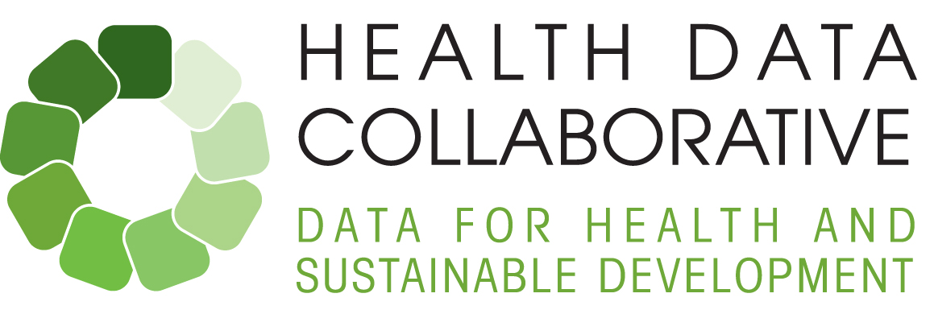



**Monthly Update – Sept. 12, 2016**

# Welcome to the eighth issue of the [Health Data Collaborative](http://www.healthdatacollaborative.org/) Monthly Update. We are pleased to bring you the latest news from the Collaborative's partners, who are adopting a more harmonized approach, aligned with country priorities, to strengthening national health information systems, improving the quality of health data and tracking progress toward the health-related Sustainable Development Goals. Please [join the conversation](https://twitter.com/HealthDataColl) on Twitter.

# Country Activities

|  |
| --- |
| **Sierra Leone Assumes Leadership of Interoperability Efforts**  Ministry of Health and Sanitation (MoHS)’s Directorate of Policy, Planning and Information (DPPI) has assumed leadership to develop a unified national architecture for its health information systems (HIS) as stated in the Bintumani Declaration, an outcome from a meeting on HIS interoperability on Aug. 2-4. This paves the way for centralized coordination of efforts to integrate and oversee existing systems and to prevent parallel, disease-specific systems from emerging. The meeting was supported by a USAID grant as part of its post-Ebola rebuilding effort and was convened by the Chief Medical Officer within MoHS. The 3-day meeting was attended by various programme Directorate leads within MoHS, WHO, IntraHealth, UNICEF, CDC, JICA, PATH, Open HIE and Liberia MoH’s Luke Bawo, who shared his experience with HIS development. The full meeting report can be viewed [here](http://www.healthdatacollaborative.org/fileadmin/uploads/hdc/Documents/SL_HIS_Interoperability_Meeting_Report_Final__2_.pdf). Follow-up actions include:   * Draft standards for data integration and interoperability so systems can be linked for easy sharing of data across systems * Draft standards for integrating mobile applications with DHIS2 * Document and map existing systems in use * Incorporate meeting outputs into the development of the HIS Strategic Plan * Explore Sierra Leone experience as case study for HDC Digital Health Systems and Interoperability working group’s engagement with countries   **Liberia prepares for National Health Sector Joint Review Conference**  Health partners will meet with the Ministry of Health later this month in preparation for the National Health Sector Joint Review Conference slated for late October. One of the key areas currently being assessed is harmonization of a monitoring and evaluation framework. |

# Working Group Activities

* **HDC Facility Surveys sub-working group**: WHO, USAID, World Bank, UNICEF & UNFPA met in Washington, D.C. on Aug. 24-25 as part of the HDC Facility and Community Data working group to advance work on harmonizing facility survey indicators across current facility assessments. It was agreed that in addition to the global standards work on indicators and modules, that agencies will seek to join forces to explore more coordinated/joint approaches to supporting facility surveys in a select number of countries.
* **HDC Community Data sub-working group:**   The Global Fund has committed to funding a number of the deliverables being undertaken by this sub-working group, which falls under the Facility and Community Data working group. A consortium led by the University Oslo with Akros and experts on HMIS/CHIS will undertake the work under the technical oversight of the group. Members met with the Global Fund and the University of Oslo consortium August 29-30 in Geneva to discuss the deliverables in detail. A meeting report with notes as well as a draft workplan from the University of Oslo consortium will be shared soon.
* **HDC Measurement of Quality of Care sub-working group meeting:** This group (also part of the Facility and Community Data working group) held its first leadership meeting on Aug. 29-31 in Geneva, where the group 1) revisited the goals and scope of the working group, 2) reviewed the current work plan and partnership engagement plans, and 3) discussed how it might engage with Kenya’s Ministry of Health, which has set Quality of Care as one of its M&E priority areas.
* **Routine health information systems curriculum:** Further to the June workshop in India, the curriculum has been reviewed and updated and slated for publication by end of September. This has been aligned with other health information system tools including core indicators, data quality analyses, and best practice for governance.

*Please visit the*[*SharePoint*](https://workspace.who.int/sites/hdc/pages/home.aspx)*to access documents on Health Data Collaborative work by country and by working group. To obtain login access to this internal documents portal, please contact Florence Rusciano at*[*ruscianof@who.int*](mailto:ruscianof@who.int)*.*

# Other Global Activities

* **Global Partnership for Sustainable Development Data Workshop on SDG Roadmaps and Data Ecosystems** in Nairobi, Aug. 15-16: Kenya Ministry of Health’s Dr Isabella Maina gave a presentation on the Kenya Health Data Collaborative, launched in May. For more details, please visit: http://stateofdata.net/
* **6th Tokyo International Conference on African Development (TICAD-VI), with side event on Universal Health Coverage in Africa** (Nairobi, Kenya) Aug. 27-28: Links to UHC-related documents from the conference:

-Framework document: <http://www.who.int/health_financing/documents/uhc-africa-action-framework/en/>   
-Event web stream: <http://live.worldbank.org/universal-health-care-africa>

-Press release (WHO AFRO): <http://www.afro.who.int/en/media-centre/pressreleases/item/8960-the-world-health-organization-releases-a-report-on-health-financing-in-africa.html>

-Press release (WBG): <http://www.worldbank.org/en/news/press-release/2016/08/26/partners-launch-framework-to-accelerate-universal-health-coverage-in-africa-world-bank-and-global-fund-commit-24-billion>

-WHO DG’s full speech at the event: <http://www.who.int/dg/speeches/2016/universal-health-africa/en/>

-Event web stream: <http://live.worldbank.org/universal-health-care-africa>

# Communications Tools

* **The Health Data Collaborative**[**website**](http://www.healthdatacollaborative.org/news): please contact communications officer Maki Kitamura at [kitamuram@who.int](mailto:kitamuram@who.int) for any content suggestions and blog entry proposals.

# Calendar of Events

|  |  |
| --- | --- |
| Sept. 15 | HDC Health Workforce WG meeting (dial-in) |
| Sept. 15 | HDC Steering Group meeting (Washington, DC) |
| Sept. 19-23 | Joint Global Fund-University of Oslo mission to Sierra Leone to strengthen in-country DHIS2 capacity |
| Sept. 22 | Global Health Agency Leaders meeting (New York) |
| Sept. 22 | Side Event on Universal Health Coverage at 71st session of UN General Assembly (New York) |
| Sept. 29 | Monthly HDC core team/working group leads call (dial-in) |
| Oct. 5 | 8th meeting of Global CRVS Group, (UNICEF headquarters, New York) |
| Oct. 5-7 | Multi-stakeholder workshop on Sierra Leone health systems strengthening, community and digital health (Freetown) |

Best wishes,

The Health Data Collaborative communications team