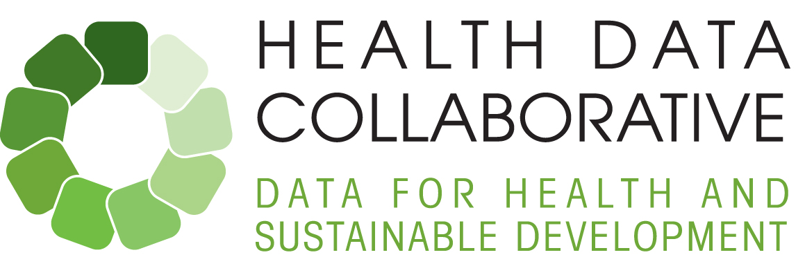



**Monthly update – March 2016**

Dear colleagues,

Many thanks to all of you for your ongoing support and inputs to the Health Data Collaborative this last month through the core team, working groups, country efforts, and the launch event. Below please find our third monthly update and highlights of upcoming events.

# 1. Country updates

Please see the attached country matrix for an overview of country engagement by the Health Data Collaborative. Some highlights below:

**Liberia:** A joint partner mission to assess the country M&E capacities in the context of the IHP+ Compact signature took place 14 -18 March. A document outlining priority actions resulting from this mission and related planned activities is attached. The document builds on the current work of in-country partners (e.g., HIS assessment, HIS strategic plan), and on the outputs of the M&E workshop conducted during the mission.

**Kenya:** Further to the request from the Permanent Secretary of the Ministry of Health in Kenya, the Ministry of Health is proposing a multi-partner mission for a high level launch of the Health Data Collaborative work starting week of **16-20 May**. The mission would include representation from the sector players, counties, partners (donors and implementing partners); civil society; leaders; line ministries including finance, the Department of births and deaths registration as well as high level meetings with the MOH leadership. Key priorities identified by the MOH as opportunities for collective action include: (1) Analytical support for the mid-term evaluation of the sector strategic plan, including subnational analyses; (2) Alignment of investments in Kenya’s HMIS; (3) Review of quality of care monitoring; (4) enhancement of the Kenya Health Observatory. The MoH is currently preparing a concept note and invitations. Please advise Kathleen Tiffay ([tiffayk@who.int](mailto:tiffayk@who.int)) of your agency’s interest in participating.

**Malawi:** As a follow up to the multi-partner planning mission in November, a technical support mission by WHO will take place **7-15 April** to support the MoH in the development of the M&E framework and plan of the National Health Sector Strategic Plan. This will include working with national MoH staff, partners and other stakeholders (e.g. Ministry of Planning, National Statistics Office). It will also include alignment of the health sector and programme specific plans, and a costing exercise. The draft plan will be the basis of the M&E common investment framework, which will be discussed and eventually endorsed in a validation multi-stakeholder workshop at the end of Q2 (dates to be confirmed).

# 2. Working groups

Many thanks to all of you for your active engagement in leading and/or participating in the working group process. The first conference call for working group leads was organised on 31 March, with participation by 23 leads from 12 different agencies. The purpose of the meeting was to review progress by all working groups, highlight opportunities for synergies between groups, and clarify next steps and coordination.

Working groups will leverage existing mechanisms and build on and strengthen existing networks to deliver on the specific global and country level results outlined in the Health Data Collaborative operational workplan. Seven of the nine groups have already developed terms of reference, with others to follow soon. Next steps include moving forward with updating membership, (virtual) working group meetings to discuss ongoing work and to develop working group activity plans for 2016 – 2017. See latest on working groups attached. For those of you who have not yet done so please feel free to sign up to your groups of interest. Email to Kathleen Tiffay ([tiffayk@who.int](mailto:tiffayk@who.int)).

# 3. Outreach and Events

* **The Health Data Collaborative launch event** on March 9th during the UN Statistical Commission meeting in New York raised awareness about the Collaborative’s aim to strengthen country capacity for health data by getting an array of global partners to work together to support country needs. So far, 32 partners have made commitments to align investments and support this collective approach.
* **The Health Data Collaborative website** ([www.healthdatacollaborative.org](http://www.healthdatacollaborative.org)) was launched to coincide with the event, resulting in a vibrant twitter response. The website content will continue to evolve, including building in more links with partner sites. Please send input, ideas, and suggested links for the website to our new communications office Makiko Kitamura ([kitamuram@who.int](mailto:kitamuram@who.int)).
* **Internal communications portal:** To facilitate internal communications and to provide easy access to documents from all collaboration partners, a SharePoint site has also been established. Please contact Florence Rusciano ([ruscianof@who.int](mailto:ruscianof@who.int)) as soon as possible to obtain access to this portal site, which will be an important link among partners.

# 4. Upcoming events

* **Plans for the Regional meeting of the Collaborative for Southeast Asia 26-28 April in** Bangladesh combined with a workshop on measurement and accountability for health are well advanced under the leadership of USAID with input from the core team and regional leaders. Core team members will attend and facilitate sessions. Expected outputs include greater alignment among stakeholders on M&E support and cross-country learning and support.
* Please find below a summary of relevant upcoming events to keep an eye on, and do not hesitate to share with us information on others that might be of interest to this group.

|  |  |
| --- | --- |
| 5 April | Country engagement working group (telecon/meeting), 14:00 (Geneva time) |
| 7-8 April | Primary Health Care Performance Initiative Stakeholder meeting, Geneva |
| 7 - 15 April | Malawi mission: Technical assistance to the M&E plan |
| 26-28 April | Regional meeting of the Collaborative for Southeast Asia in Bangladesh |
| April (tbc) | Global Health Agency Leaders meeting |
| 3,4,5 May | Facility and Community Data Working group meeting, Geneva |
| 16-19 May (tbc) | Kenya mission: Technical assistance to review and Health Data Collaborative launch |

Thanks and best regards,

Kathy & Ties on behalf of the core team

**Attachments:** Updated Operational Workplan | Working Group Terms of Reference | Country Matrix | Liberia priority actions