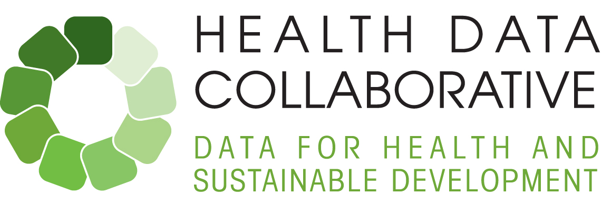



**Monthly update – April 2016**

Dear colleagues,

Welcome to the fourth monthly update highlighting recent and upcoming events related to the Health Data Collaborative:

# 1. Country updates

Please see the [SharePoint](https://workspace.who.int/sites/hdc/pages/home.aspx) to access the country matrix for a full overview of HDC activity. (If you haven’t done so already, please contact Florence Rusciano at [ruscianof@who.int](mailto:ruscianof@who.int) to obtain login access to this internal documents portal.)

* 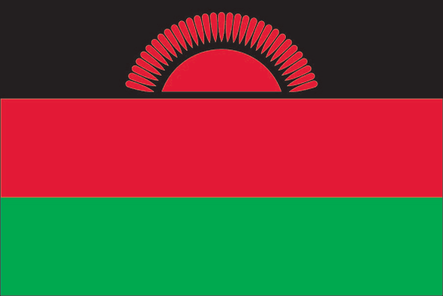 **Malawi:** Working under the leadership of the monitoring and evaluation (M&E) task force and the Ministry of Health Directorate of Planning and as a follow-up to the HDC mission in Malawi in November, WHO provided technical support in early April toward the development of the M&E component of the new health sector strategic plan (HSSP II). This included selection of core health indicators; mapping current HIS/M&E activities; and discussion of M&E priority actions. HDC partners’ country counterparts were instrumental in this work, including GIZ, BMGF, UNICEF, CDC and USAID, among others. Follow-up in May will involve alignment of indicators and costing of activities. The common investment framework will be developed after this for partner validation.
* 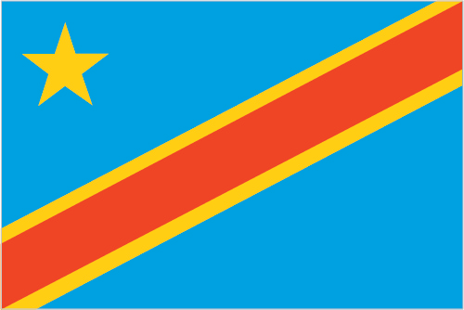 **DRC:** The MoH requested support to develop the M&E framework of the recently approved National Health Strategic Plan (PNDS 2016-2020). In this context, a technical assistance mission is underway to support the development of the framework and to explore further engagement by HDC partners.
* 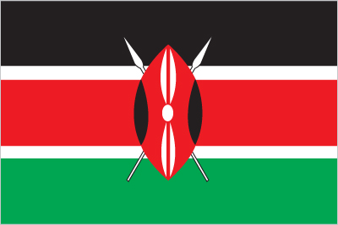 **Kenya:** Health Data Collaborative work in Kenya will be launched May 16-20. The mission will include representation from sector players, donors, partners, civil society, the department of births and deaths registration as well as high-level meetings with Ministry of Health leadership. Key priorities identified by the MoH as opportunities for collective action include: (1) Analytical support for the mid-term evaluation of the sector strategic plan; (2) Alignment of investments in Kenya’s health management information system (HMIS); (3) Review of quality of care monitoring; and (4) enhancement of the Kenya Health Observatory.
* **Other countries**: World Bank is currently focusing on a few countries (Liberia, Kenya, DRC, Malawi, Cambodia) where funds could be available to support collective work. Other countries (potentially Myanmar) will follow. WHO is providing technical support in Sierra Leone May 9-13 and is exploring opportunities for engagement by HDC partners.
* **Country engagement approach document:** A draft document outlining recommended steps and protocols for engaging with countries on HDC work is currently being finalized by core team members.

# 2. Working Groups

* **Facility and Community Data working group meeting** in Glion sur Montreux, Switzerland, May 3-5: 52 technical experts from 20 global health organizations, academia and civil society gathered for the working group’s first meeting, during which four sub-groups (focused on Routine health information systems and disease surveillance; community data; facility surveys; and measurement of quality of care) worked on concrete action plans for 2016-17.
* The most recent versions of all five working groups’ terms of reference are available on the SharePoint. For those of you who have not yet done so please feel free to sign up to your groups of interest by contacting project manager Kathleen Tiffay ([tiffayk@who.int](mailto:tiffayk@who.int)).

# 3. Outreach and Events

* **Primary Health Care Improvement stakeholder meeting**, April 7-8 in Geneva: While the focus of the meeting was Primary Health Care and quality of care improvement, data plays an important role. It was agreed that Health Data Collaborative partners are committed to strengthening measures of quality of care and performance, which will be addressed by one of the HDC working groups.
* **Global Health Agency Leaders Meeting**, April 13 at the World Bank headquarters in Washington, DC: The World Bank Group and WHO co-chaired the meeting where leaders reported that the HDC has established working groups and now has technical and financial alignment to support better data, data quality, and local and national analytical capacity.
* **Regional meeting of the Collaborative for Southeast Asia,** April 26-28 in Dhaka, Bangladesh: the meeting provided an opportunity to hear about the experiences of countries in the region in monitoring their health strategies and to identify opportunities for working more effectively in data-driven public health. Please see the [HDC website](http://www.healthdatacollaborative.org/news) for blog posts from the meeting.
* **UN Foundation to host multi-stakeholder meeting** May 12 in Washington, DC: NGOs, UN and other agencies and advocacy groups have been invited to an informal stakeholder discussion hosted by UN Foundation to raise the profile of the Health Data Collaborative. Please contact Caroline Barrett ([CBarrett@unfoundation.org](mailto:CBarrett@unfoundation.org)) for more details.

# 4. Communications tools

* **Communique to HDC partners’ country counterparts:** adraft document has been circulated to core team members for final comments. The document, intended to be distributed widely, serves to communicate the broad objectives of the Collaborative and how it will operate at the country level.
* **The Health Data Collaborative** [**website**](http://www.healthdatacollaborative.org/news): a News section has been added with content from the launch event in March and from the Bangladesh regional meeting. Please contact communications officer Maki Kitamura ([kitamuram@who.int](mailto:kitamuram@who.int)) for any content submissions/suggestions.

# 5. Upcoming events

|  |  |
| --- | --- |
| May 9-13 | M&E/HIS scoping mission in Sierra Leone |
| May 12 | UN Foundation hosts HDC stakeholder briefing in Washington, D.C. |
| May 16-19 | Kenya mission: Technical assistance and Health Data Collaborative launch |

Thanks and best regards,

The HDC communications team